1. turn off the radio, plug programming cable.

2. Press and hold the side key 1 and the side key 2 to turn on the radio. The radio will be in upgrade mode when the indicator light is on.

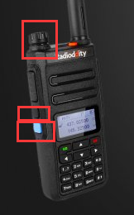

3.Open the upgrade software "Update.exe"

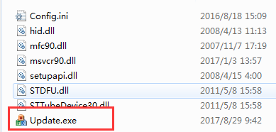

4. Click "Browse" to select the file to be upgraded, for example: GD-77_V3.1.3.sgl,

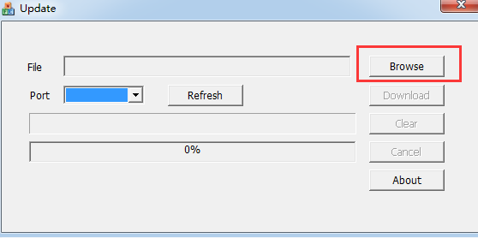

5. Click "Download" to complete the upgrade.

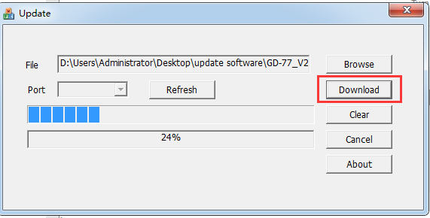

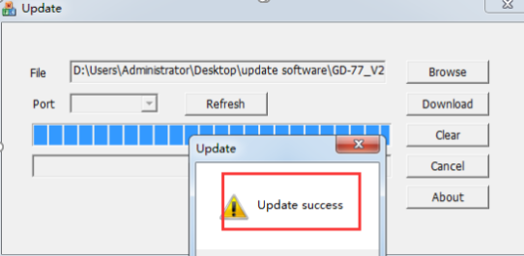

6. Unplug programming cable, turn off radio or reboot

V2.6.9update content:

1：128 RX Group List

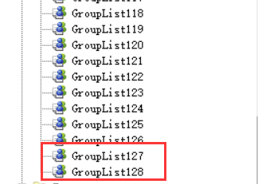

2：ZONE Abnormal Repair 。

V2.6.6 update content:

1：2.5K step

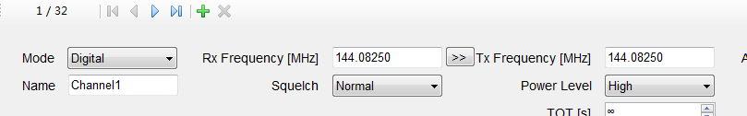

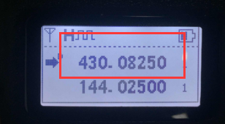

2：The backlight can be turned off：

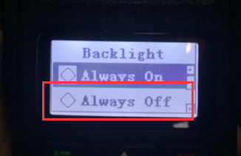 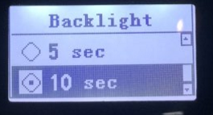

V2.6.3 update content:

ADD TX Exit Tone :

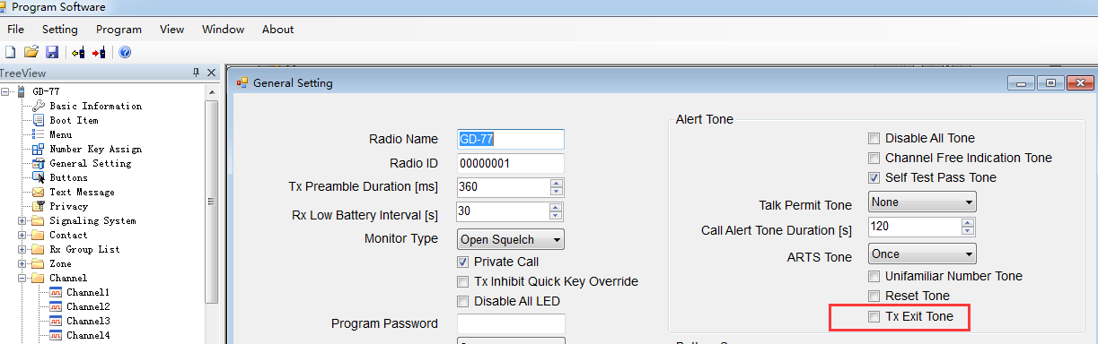

V2.6.1 update content:

1: Promiscuous mode: CC（Colour Code） and TS （TimeSlot）to the same，TG（TalkGroup） 、Private Call ID can be different。

Promiscuous mode Switch:

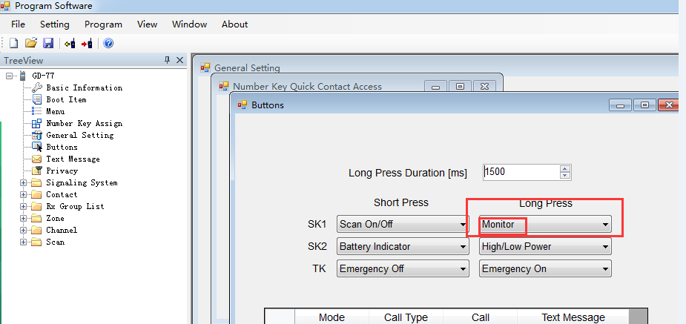

2:1750 Europe : 1750 Switch:

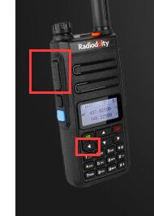Analog channel，Hold down “PTT”+Left direction button。